**11. Алгоритм Прима-Краскала (нахождение минимального остовного дерева).**

Дан взвешенный неориентированный граф:

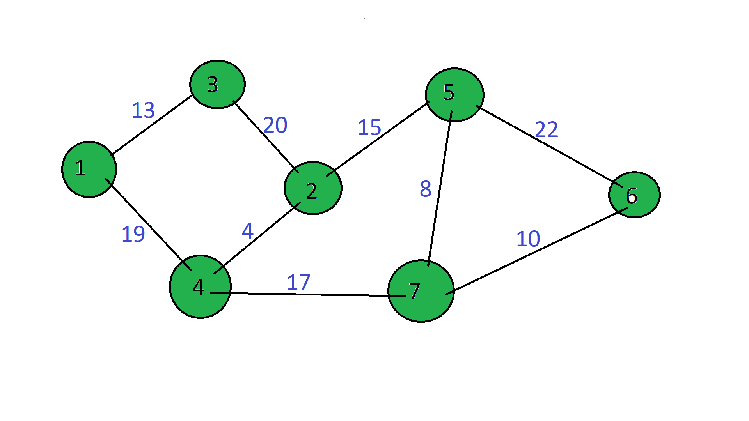

|  |  |  |  |  |  |  |  |
| --- | --- | --- | --- | --- | --- | --- | --- |
|  | **1** | **2** | **3** | **4** | **5** | **6** | **7** |
| **1** |  |  | 13 |  |  |  |  |
| **2** |  |  |  |  |  |  |  |
| **3** | 13 |  |  |  |  |  |  |
| **4** |  |  |  |  |  |  |  |
| **5** |  |  |  |  |  |  |  |
| **6** |  |  |  |  |  |  |  |
| **7** |  |  |  |  |  |  |  |

Составляем матрицу весов ребер:

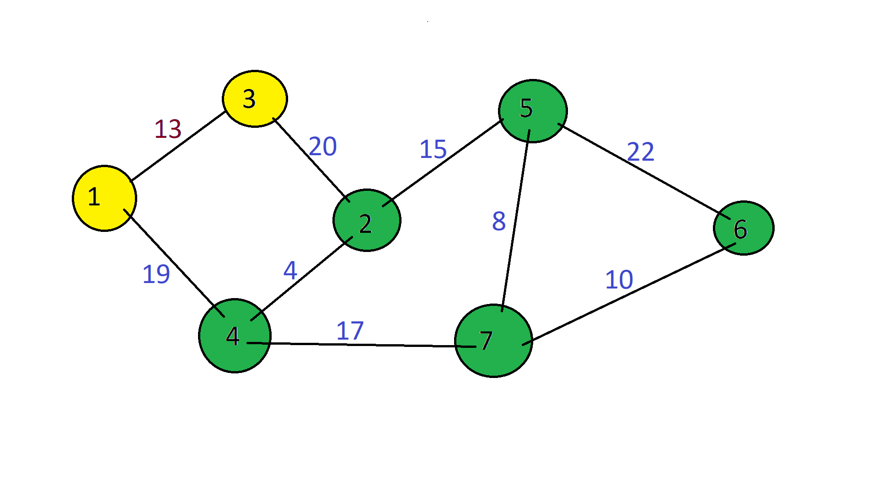

|  |  |  |  |  |  |  |  |
| --- | --- | --- | --- | --- | --- | --- | --- |
|  | **1** | **2** | **3** | **4** | **5** | **6** | **7** |
| **1** |  |  | 13 | 19 |  |  |  |
| **2** |  |  |  |  |  |  |  |
| **3** | 13 |  |  |  |  |  |  |
| **4** | 19 |  |  |  |  |  |  |
| **5** |  |  |  |  |  |  |  |
| **6** |  |  |  |  |  |  |  |
| **7** |  |  |  |  |  |  |  |

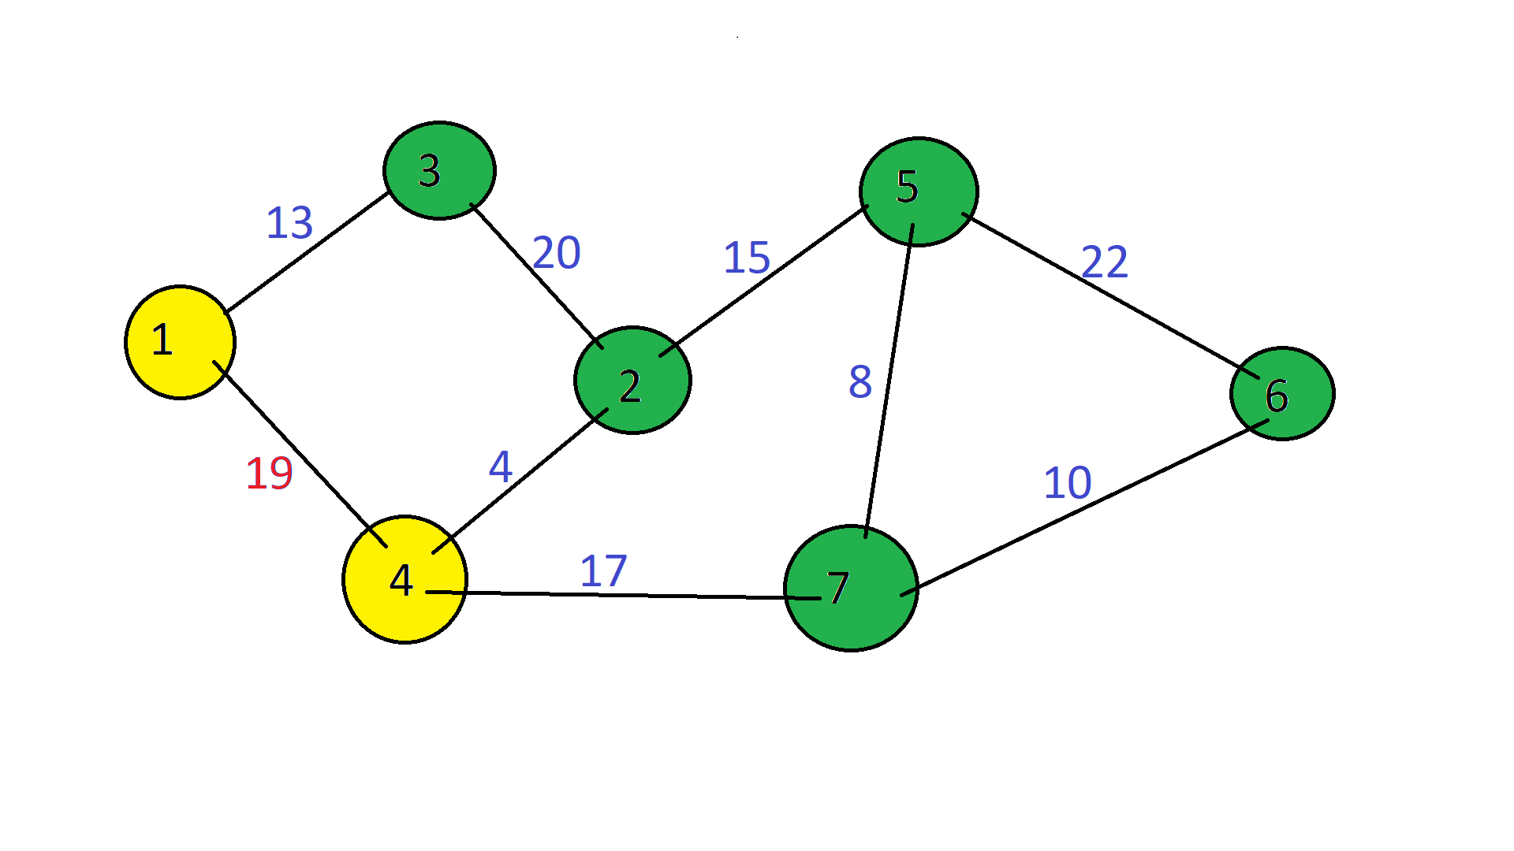

И так далее…

|  |  |  |  |  |  |  |  |
| --- | --- | --- | --- | --- | --- | --- | --- |
|  | **1** | **2** | **3** | **4** | **5** | **6** | **7** |
| **1** |  |  | 13 | 19 |  |  |  |
| **2** |  |  | 20 | 4 | 15 |  |  |
| **3** | 13 | 20 |  |  |  |  |  |
| **4** | 19 | 4 |  |  |  |  | 17 |
| **5** |  | 15 |  |  |  | 22 | 8 |
| **6** |  |  |  |  | 22 |  | 10 |
| **7** |  |  |  | 17 | 8 | 10 |  |

Находим минимальный элемент в матрице:

|  |  |  |  |  |  |  |  |
| --- | --- | --- | --- | --- | --- | --- | --- |
|  | **1** | **2** | **3** | **4** | **5** | **6** | **7** |
| **1** |  |  | 13 | 19 |  |  |  |
| **2** |  |  | 20 | 4 | 15 |  |  |
| **3** | 13 | 20 |  |  |  |  |  |
| **4** | 19 | 4 |  |  |  |  | 17 |
| **5** |  | 15 |  |  |  | 22 | 8 |
| **6** |  |  |  |  | 22 |  | 10 |
| **7** |  |  |  | 17 | 8 | 10 |  |

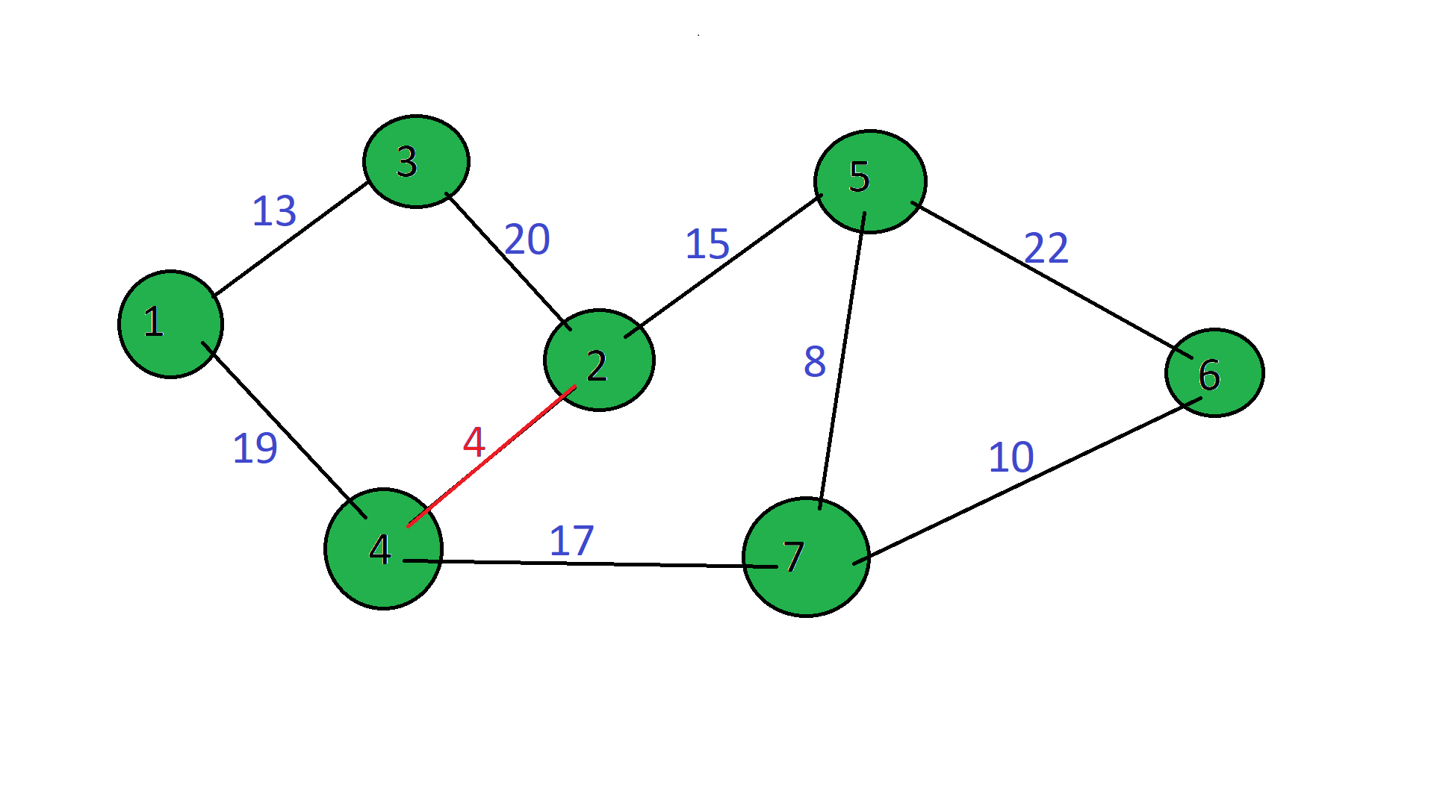

Вычеркиваем 2-ю и 4-ю строки, 2-ой и 4-ой столбцы помечаем:

|  |  |  |  |  |  |  |  |
| --- | --- | --- | --- | --- | --- | --- | --- |
|  | **1** | **2\*** | **3** | **4\*** | **5** | **6** | **7** |
| **1** |  |  | 13 | 19 |  |  |  |
| **2** |  |  |  | 4 |  |  |  |
| **3** | 13 | 20 |  |  |  |  |  |
| **4** |  |  |  |  |  |  |  |
| **5** |  | 15 |  |  |  | 22 | 8 |
| **6** |  |  |  |  | 22 |  | 10 |
| **7** |  |  |  | 17 | 8 | 10 |  |

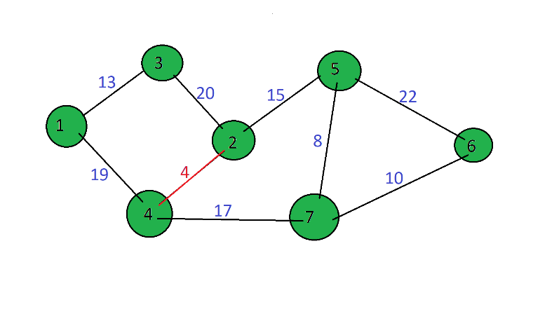

Из помеченных выбираем минимальный элемент:

|  |  |  |  |  |  |  |  |
| --- | --- | --- | --- | --- | --- | --- | --- |
|  | **1** | **2\*** | **3** | **4\*** | **5** | **6** | **7** |
| **1** |  |  | 13 | 19 |  |  |  |
| **2** |  |  |  | 4 |  |  |  |
| **3** | 13 | 20 |  |  |  |  |  |
| **4** |  |  |  |  |  |  |  |
| **5** |  | 15 |  |  |  | 22 | 8 |
| **6** |  |  |  |  | 22 |  | 10 |
| **7** |  |  |  | 17 | 8 | 10 |  |

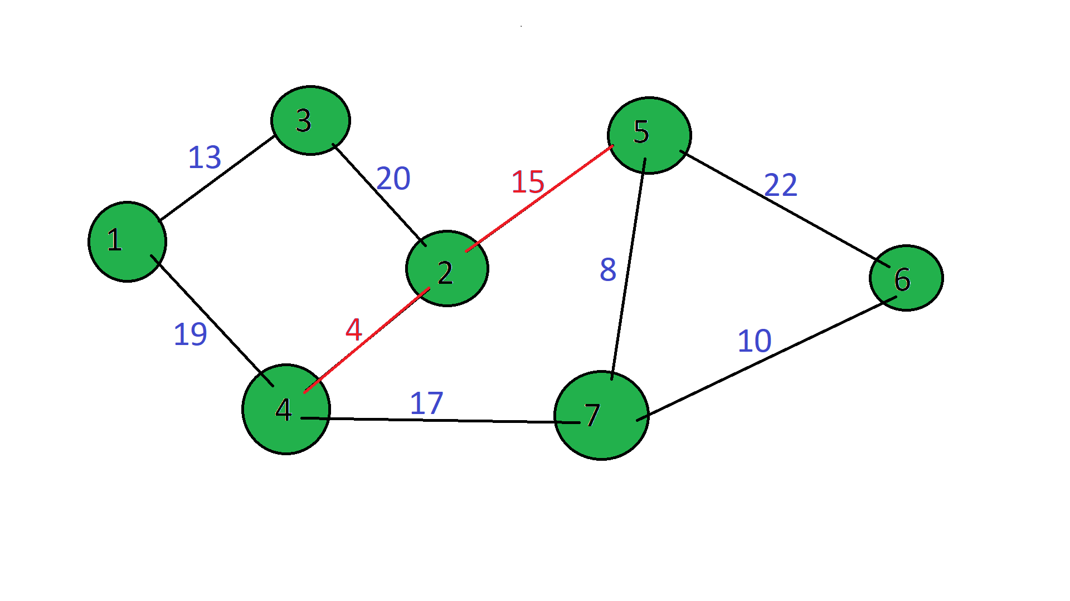

Вычеркиваем 5-ую строку. Помечаем 5-ый столбец:

|  |  |  |  |  |  |  |  |
| --- | --- | --- | --- | --- | --- | --- | --- |
|  | **1** | **2\*** | **3** | **4\*** | **5\*** | **6** | **7** |
| **1** |  |  | 13 | 19 |  |  |  |
| **2** |  |  |  | 4 |  |  |  |
| **3** | 13 | 20 |  |  |  |  |  |
| **4** |  |  |  |  |  |  |  |
| **5** |  | 15 |  |  |  |  |  |
| **6** |  |  |  |  | 22 |  | 10 |
| **7** |  |  |  | 17 | 8 | 10 |  |

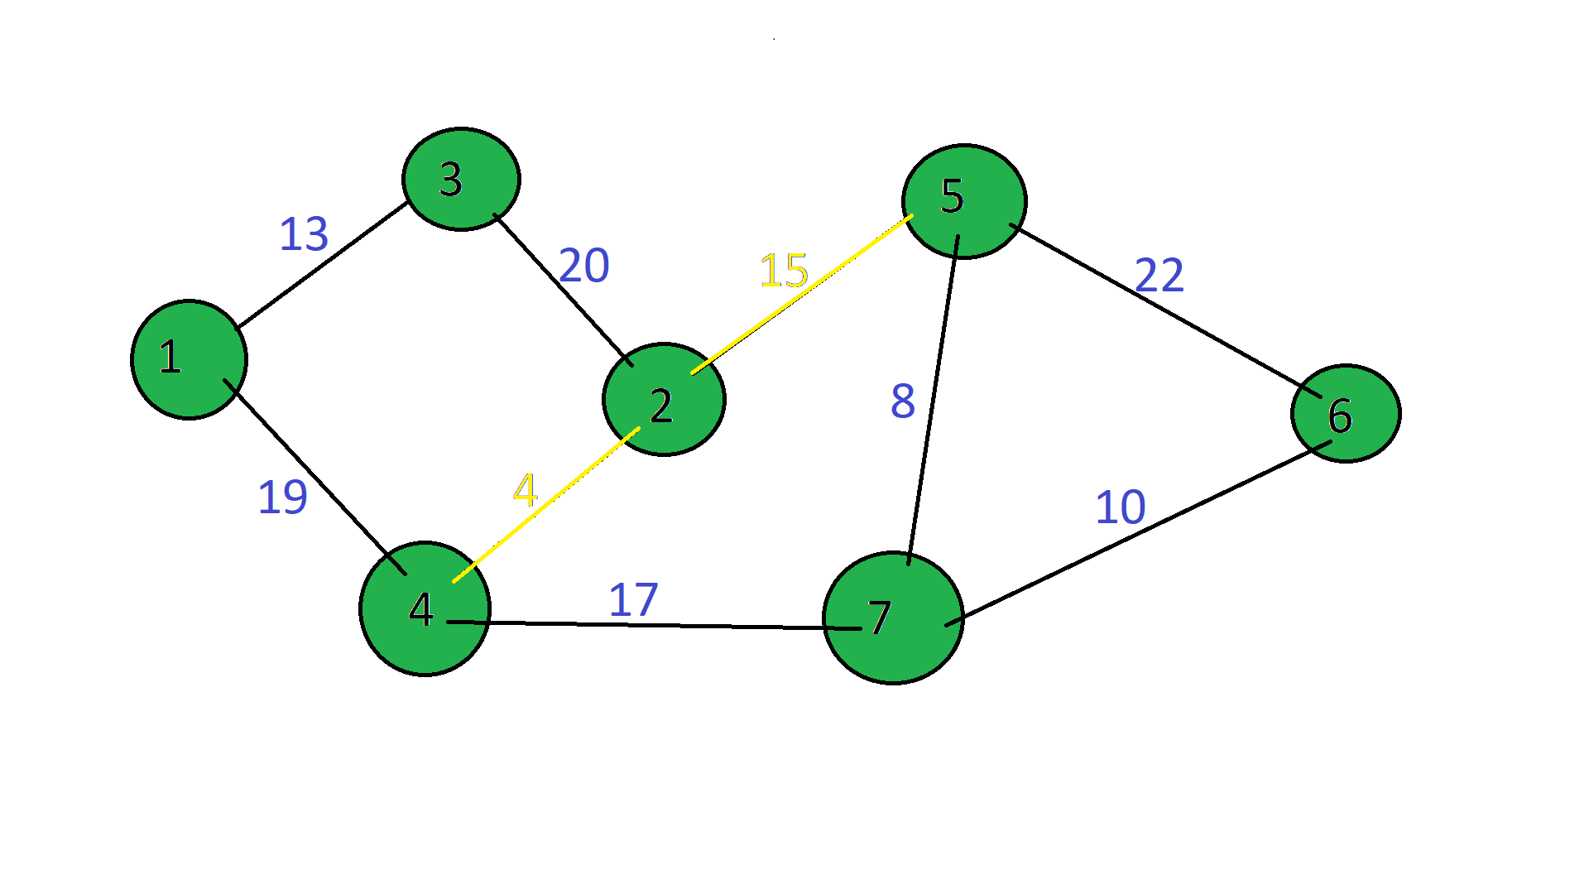

Из помеченных выбираем минимальный элемент:

|  |  |  |  |  |  |  |  |
| --- | --- | --- | --- | --- | --- | --- | --- |
|  | **1** | **2\*** | **3** | **4\*** | **5\*** | **6** | **7** |
| **1** |  |  | 13 | 19 |  |  |  |
| **2** |  |  |  | 4 |  |  |  |
| **3** | 13 | 20 |  |  |  |  |  |
| **4** |  |  |  |  |  |  |  |
| **5** |  | 15 |  |  |  |  |  |
| **6** |  |  |  |  | 22 |  | 10 |
| **7** |  |  |  | 17 | 8 | 10 |  |

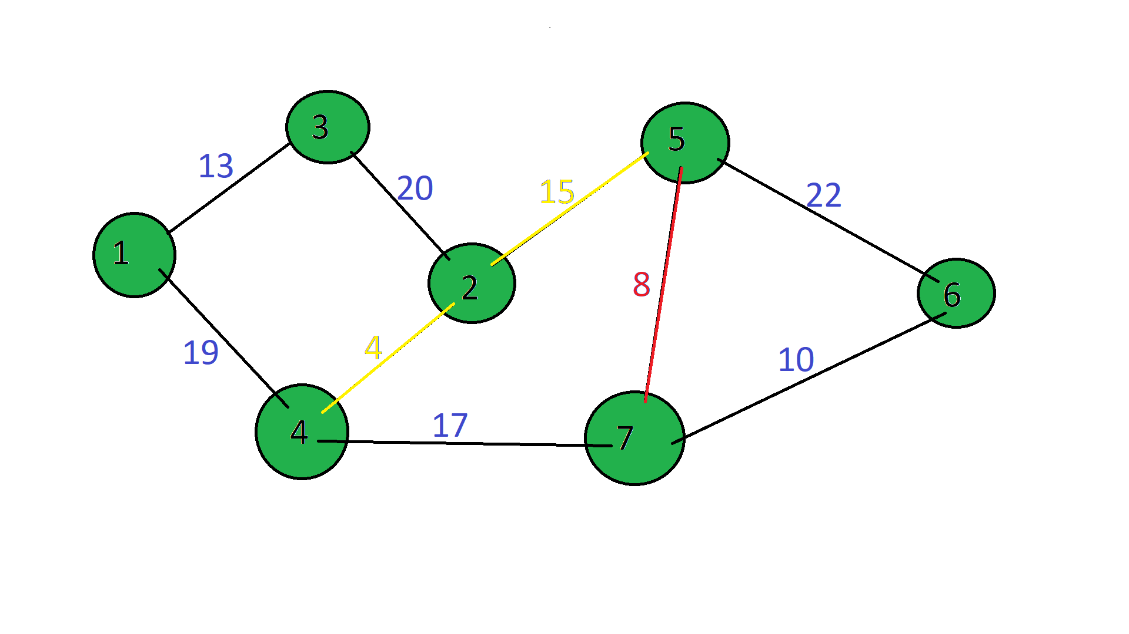

Вычеркиваем 7-ую строку. Помечаем 7-ый столбец:

|  |  |  |  |  |  |  |  |
| --- | --- | --- | --- | --- | --- | --- | --- |
|  | **1** | **2\*** | **3** | **4\*** | **5\*** | **6** | **7\*** |
| **1** |  |  | 13 | 19 |  |  |  |
| **2** |  |  |  | 4 |  |  |  |
| **3** | 13 | 20 |  |  |  |  |  |
| **4** |  |  |  |  |  |  |  |
| **5** |  | 15 |  |  |  |  |  |
| **6** |  |  |  |  | 22 |  | 10 |
| **7** |  |  |  |  | 8 |  |  |

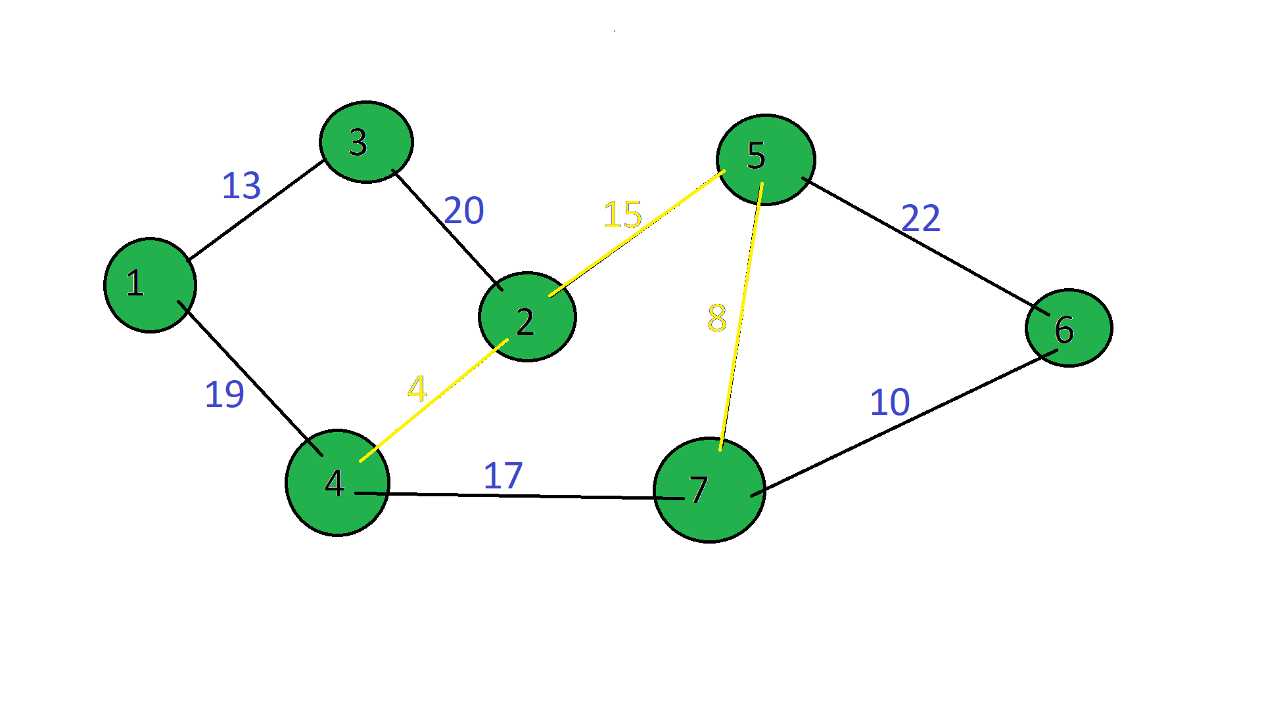

Из помеченных выбираем минимальный элемент:

|  |  |  |  |  |  |  |  |
| --- | --- | --- | --- | --- | --- | --- | --- |
|  | **1** | **2\*** | **3** | **4\*** | **5\*** | **6** | **7\*** |
| **1** |  |  | 13 | 19 |  |  |  |
| **2** |  |  |  | 4 |  |  |  |
| **3** | 13 | 20 |  |  |  |  |  |
| **4** |  |  |  |  |  |  |  |
| **5** |  | 15 |  |  |  |  |  |
| **6** |  |  |  |  | 22 |  | 10 |
| **7** |  |  |  |  | 8 |  |  |

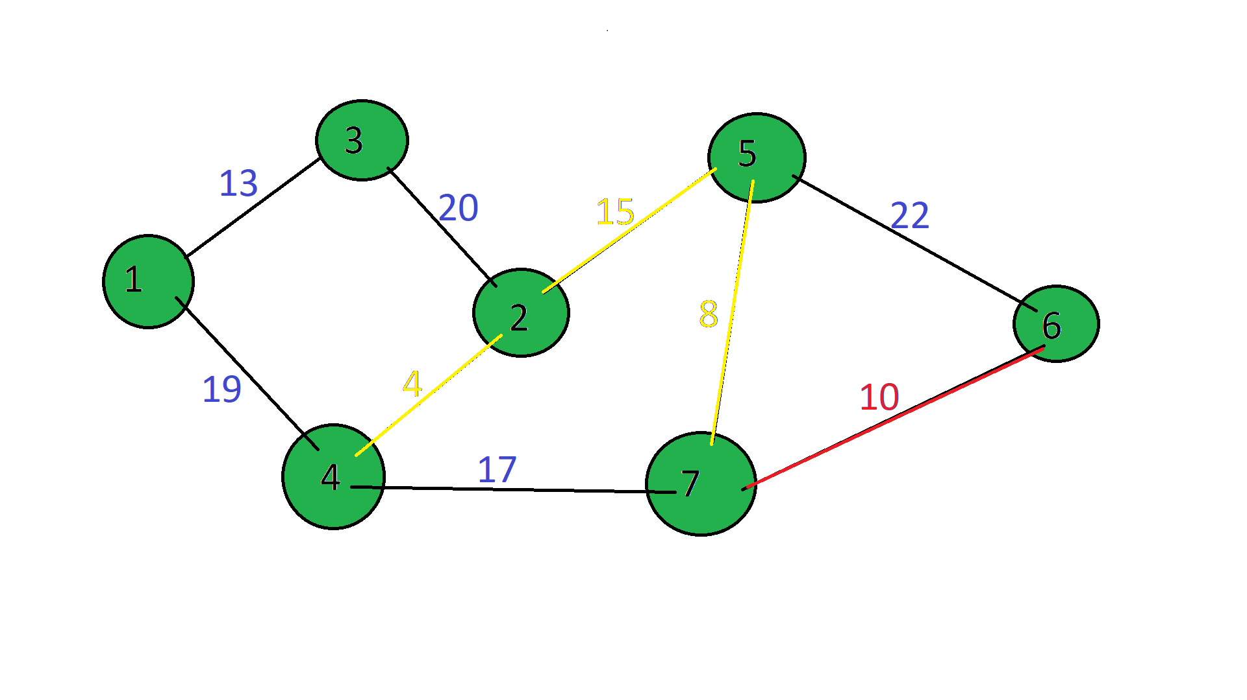

Вычеркиваем 6-ую строку. Помечаем 6-ый столбец:

|  |  |  |  |  |  |  |  |
| --- | --- | --- | --- | --- | --- | --- | --- |
|  | **1** | **2\*** | **3** | **4\*** | **5\*** | **6\*** | **7\*** |
| **1** |  |  | 13 | 19 |  |  |  |
| **2** |  |  |  | 4 |  |  |  |
| **3** | 13 | 20 |  |  |  |  |  |
| **4** |  |  |  |  |  |  |  |
| **5** |  | 15 |  |  |  |  |  |
| **6** |  |  |  |  |  |  | 10 |
| **7** |  |  |  |  | 8 |  |  |

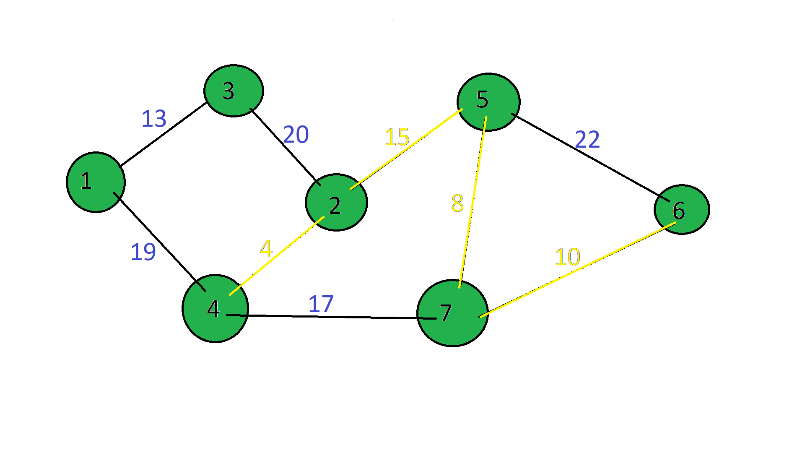

Из помеченных выбираем минимальный элемент:

|  |  |  |  |  |  |  |  |
| --- | --- | --- | --- | --- | --- | --- | --- |
|  | **1** | **2\*** | **3** | **4\*** | **5\*** | **6\*** | **7\*** |
| **1** |  |  | 13 | 19 |  |  |  |
| **2** |  |  |  | 4 |  |  |  |
| **3** | 13 | 20 |  |  |  |  |  |
| **4** |  |  |  |  |  |  |  |
| **5** |  | 15 |  |  |  |  |  |
| **6** |  |  |  |  |  |  | 10 |
| **7** |  |  |  |  | 8 |  |  |

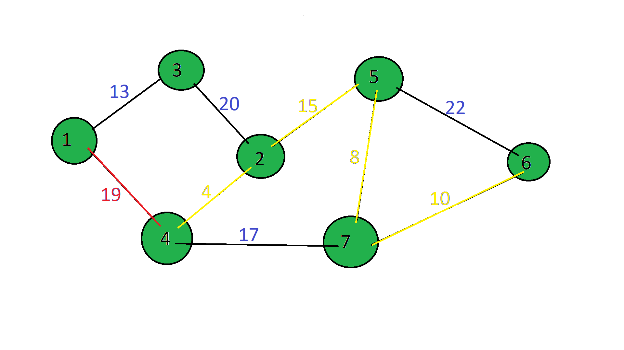

Вычеркиваем 6-ую строку. Помечаем 6-ый столбец:

|  |  |  |  |  |  |  |  |
| --- | --- | --- | --- | --- | --- | --- | --- |
|  | **1\*** | **2\*** | **3** | **4\*** | **5\*** | **6\*** | **7\*** |
| **1** |  |  |  | 19 |  |  |  |
| **2** |  |  |  | 4 |  |  |  |
| **3** | 13 | 20 |  |  |  |  |  |
| **4** |  |  |  |  |  |  |  |
| **5** |  | 15 |  |  |  |  |  |
| **6** |  |  |  |  |  |  | 10 |
| **7** |  |  |  |  | 8 |  |  |

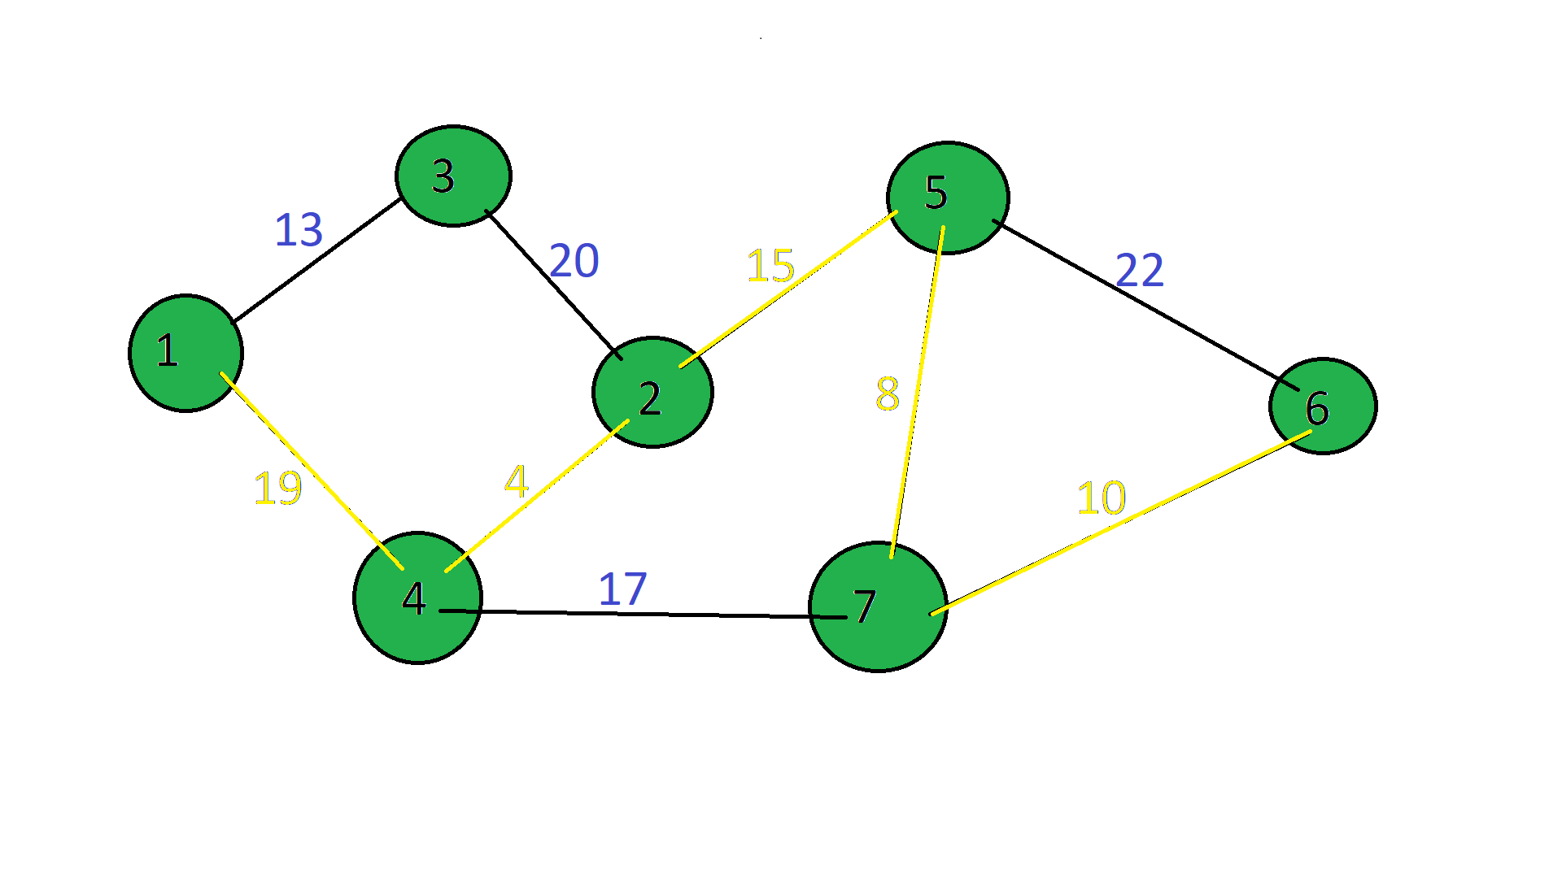

Из помеченных выбираем минимальный элемент:

|  |  |  |  |  |  |  |  |
| --- | --- | --- | --- | --- | --- | --- | --- |
|  | **1\*** | **2\*** | **3** | **4\*** | **5\*** | **6\*** | **7\*** |
| **1** |  |  |  | 19 |  |  |  |
| **2** |  |  |  | 4 |  |  |  |
| **3** | 13 | 20 |  |  |  |  |  |
| **4** |  |  |  |  |  |  |  |
| **5** |  | 15 |  |  |  |  |  |
| **6** |  |  |  |  |  |  | 10 |
| **7** |  |  |  |  | 8 |  |  |

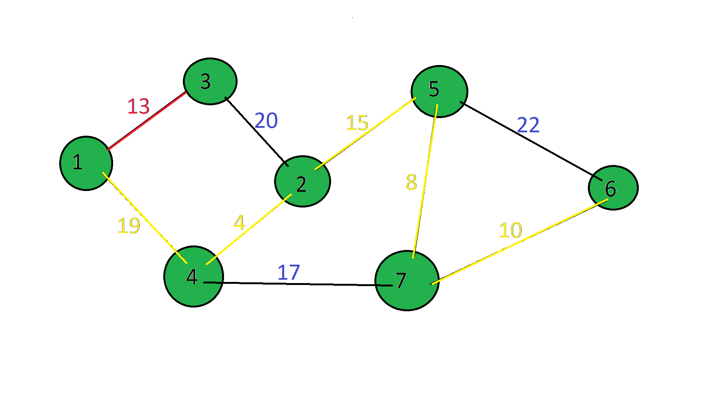

|  |  |  |  |  |  |  |  |
| --- | --- | --- | --- | --- | --- | --- | --- |
|  | **1** | **2** | **3** | **4** | **5** | **6** | **7** |
| **1** |  |  |  | 19 |  |  |  |
| **2** |  |  |  | 4 |  |  |  |
| **3** | 13 |  |  |  |  |  |  |
| **4** |  |  |  |  |  |  |  |
| **5** |  | 15 |  |  |  |  |  |
| **6** |  |  |  |  |  |  | 10 |
| **7** |  |  |  |  | 8 |  |  |

Получили минимальное остовное дерево

